
UNIVERSITY OF BUEA

FACULTY OF ENGINEERING AND TECHNOLOGY
(FET)
PO BOX 63

REPUBLIC OF CAMEROON

PEACE-WORK-FATHERLAND
BUEA, SOUTH WEST REGION

TASK 3 REPORT
Requirement Analysis For a Crowdsensed Drive Test Mobile Application for Coverage Prediction

COURSE TITLE: INTERNET PROGRAMMING AND
MOBILE PROGRAMMING
COURSE CODE: CEF 440
COURSE INSTRUCTOR: DR NKAMENI VALERY

- GROUP 13 MEMBERS
1. IMELE AZAFA JOSE DE KAJOS ------------------------------------FE23A068
2. AYUK AMELIA AGBOR OROCK------------------------------------ FE23A020
3.NGOME FERNANDEZ MANYAKA---------------------------------- FE23A111
4.TADJEU NGNINTEDEM AUBRY-JUNEX-------------------------- FE23A148
5.BESSONG TAKANG TABOT WILLY--------------------------------- FE23A025
DEPARTMENT OF COMPUTER ENGINEERING
ACADEMIC YEAR 2025 - 2026

Table of Contents
INTRODUCTION 1
1. Requirement Review and Analysis 2
1.1 Completeness 2
1.2 Clarity 2
1.3 Technical Feasibility 3
1.4 Dependency Relationships 4
2. Inconsistencies, Ambiguities, and Missing Information 6
2.1 Inconsistencies Found 6
2.1.1 Battery Efficiency vs Real-Time Data Collection 6
2.1.2 WiFi-Only Upload vs Live Coverage Map 7
2.1.3 Full Anonymity vs Device Consistency for ML 7
2.1.4 Collection Timing Preference 7
2.2 Ambiguities Resolved 7
2.3 Missing Information 8
2.3.1 Mobile Application Gaps 8
2.3.2 Backend Server Gaps 9
2.3.3 ML Coverage Prediction Gaps 9
3. Requirement Prioritization 10
3.1 Evidence Base 11
3.1.1 Survey Findings (100 Smartphone Users, Buea) 11
3.1.2 Engineer Interview Findings (MTN & Orange) 11
3.1.3 Reverse Engineering (OpenSignal, Network Cell Info Lite) 11
3.2 Priority Matrix 12
3.3 Summary by Priority 14
3.4.1 Must Have Requirements 14
3.4.2 Should Have Requirements 14
3.4.3 Could Have Requirements 15
3.4.4 Won't Have (Current Phase) 15
4. Requirement Classification 16
Classification Framework 16
4.1 Functional Requirements 16
4.2 Non-Functional Requirements 17
5. Software Requirements Specification (SRS) 19
5.1 Introduction 19
5.1.1 Purpose 19
5.1.2 Document Conventions 19
5.1.3 Intended Audience 19
5.1.4 Project Scope 19
5.1.5 Key Definitions 20
5.2 Overall Description 20
5.2.1 Product Perspective 20
5.2.2 User Classes 20
5.2.3 Operating Environment 21
5.2.4 Constraints 21
5.2.5 Assumptions and Dependencies 21
5.3 System Features 21
5.3.1 Functional Requirements 21
5.4 External Interface Requirements 22
5.4.1 User Interface 22
5.4.2 Hardware Interfaces 22
5.4.3 Software Interfaces 22
5.4.4 Communication Interfaces 22
5.5 Non-Functional Requirements 22
5.5.1 Performance 22
5.5.2 Resource Constraints 22
5.5.3 Security 23
5.5.4 Reliability 23
5.5.5 Usability 23
5.5.6 ML Accuracy 23
6. Validation with Stakeholders 24
6.1. Introduction 24
6.2. Why Validation is Important 24
6.3. Stakeholders Validation Methods 25
6.4. Validation Techniques 26
6.5. Validation checklist 27
6.6 Validation Outcomes 28
CONCLUSION 29

INTRODUCTION
This report presents the full requirement analysis for CrowdSenseNet: a Crowdsensed Drive Test Mobile Application designed to solve the problem of inconsistent mobile network coverage in Cameroon. The work builds directly on the requirements gathered in Task 2, where the team collected information through four methods: surveys of 102 smartphone users, interviews with network engineers at MTN and Orange, team brainstorming sessions, and reverse engineering of existing apps such as OpenSignal and Network Cell Info Lite.

Task 3 takes all of that raw material and puts it through a structured analysis process. We reviewed the requirements for completeness, clarity, technical feasibility, and dependencies. We found and resolved inconsistencies, cleared up ambiguities, and filled in missing information. We then prioritised the requirements using the MoSCoW method, classified them into functional and non-functional groups, and brought them together into a full Software Requirements Specification (SRS). The final step was validating everything with the stakeholders who will use, operate, and oversee the system.

The goal of all this work is simple: before anyone writes a single line of code, we want to be confident that we know exactly what we are building, why we are building it, and that the people it affects have agreed that it meets their needs.

Figure 1: Overview of the Task 3 requirement analysis process

1. Requirement Review and Analysis
We obtained requirements from four sources in Task 2: MNO engineer interviews, a user survey with 102 responses, team brainstorming sessions, and reverse engineering of OpenSignal and NetMonster. Before using those requirements to design anything, we reviewed them across four areas: completeness, clarity, technical feasibility, and dependency relationships.

1.1 Completeness
When checking for completeness, we made sure that no stakeholder need was left without a corresponding requirement. Based on the gathered information, the following areas were well covered:
- RF parameters: RSRP, SINR, RSRQ, RSSI, and throughput
- Privacy and data anonymity
- Battery efficiency
- User on/off toggle for data collection
- WiFi-only upload option

A few areas needed more detail:
- MNO interview data was partially blocked for confidentiality reasons. Some RF parameter requirements were inferred rather than formally confirmed, leaving room for further clarification.
- The GPS accuracy threshold appeared as an implied requirement in the data rather than a clearly written one. It has since been formalised.

1.2 Clarity
We identified requirements that were too vague or subjective and replaced them with clear, measurable versions. The table below shows the original wording alongside the improved version.

Original (Ambiguous) | Improved (Clear and Measurable)
App must use minimal battery | App background sensing must not increase battery drain by more than 5% per hour
Simple, clean interface usable by non-technical users | App must require no more than 3 steps to enable or disable data collection
System must support data collection in rural areas | System must store data locally when connectivity is unavailable and sync automatically when reconnected
Good GUI | App shall have 4 main screens: Home, Live Map, History, Settings. Key actions reachable within 3 taps. Supports English and French
Anonymous data | App shall not collect name, email, phone number, IMEI, or IP address
Collect signal data | App collects RSRP, RSRQ, SINR, RSSI, Cell ID, network type, GPS, timestamp, and anonymous token every 10 seconds while moving
Predict coverage holes | Coverage hole defined as predicted RSRP below -110 dBm
Works offline | Data collection, local storage, and history viewing shall work offline
Table 1.1: Original ambiguous requirements and their clarified replacements

1.3 Technical Feasibility
Each major requirement was assessed and rated as feasible, partially feasible, or not feasible within the current project scope.

Requirement | Rating | Reason
Collect RF parameters via Android API | Feasible | Android TelephonyManager API supports RSRP, SINR, RSRQ, and RSSI directly
GPS tagging per measurement | Feasible | Standard Android Location API with FusedLocationProvider
Offline local storage and auto upload | Feasible | SQLite via Room DB, background sync via WorkManager
Map-based heatmap visualisation | Partially feasible | Requires backend integration and a mapping library; achievable but complex
Multi-operator support (MTN and Orange) | Feasible | Android API automatically detects the active operator
GeoJSON export | Partially feasible | Standard format but requires backend development effort
ML-based coverage prediction | Not feasible (now) | Needs training data from a live pipeline; deferred to a later phase

Table 1.2: Technical feasibility assessment for major requirements

1.4 Dependency Relationships
Some requirements only make sense if others are already in place. We mapped those dependencies to make sure nothing gets built out of order.

Requirement | Depends On | Why
Auto upload to server | Offline local storage | Data must be stored locally before it can be uploaded
Map-based visualisation | GPS tagging and backend API | Cannot plot coverage without coordinates and a data endpoint
WiFi-only upload setting | Auto-upload feature | This is a sub-feature of the upload logic
Coverage hole flagging (RSRP below -110 dBm) | RSRP collection | Cannot flag what has not been collected
Heatmap | GeoJSON export and map visualisation | Backend must produce GeoJSON for the map to consume

Table 1.3: Requirement dependency relationships
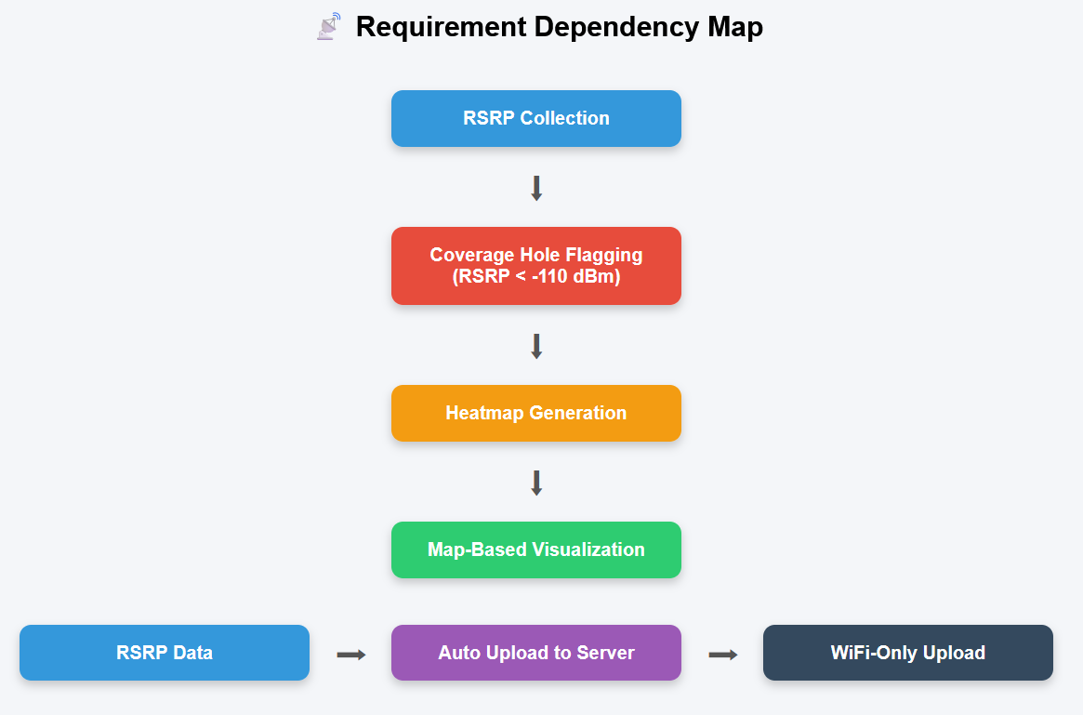
Figure 2: Requirement dependency map

2. Inconsistencies, Ambiguities, and Missing Information
In this task, the requirements gathered for the Crowdsensed Drive Test Mobile Application were analysed to identify inconsistencies, ambiguities, and missing information. This analysis ensures that the proposed system is clear, complete, reliable, and suitable for real-world deployment. By resolving these issues early, the development team can reduce errors, improve system quality, and ensure that the final MVP effectively supports mobile network coverage prediction in Cameroon.

MVP Scope
The Minimum Viable Product (MVP) covers:
• signal data collection (RSRP, RSRQ, SINR, GPS)
• local offline storage
• backend data upload
• basic coverage map
• ML coverage hole prediction.

2.1 Inconsistencies Found
An inconsistency is where two requirements ask for things that conflict with each other. We found four.

2.1.1 Battery Efficiency vs Real-Time Data Collection
Conflict: Users want real-time continuous data collection AND minimal battery usage at the same time.
Source: Survey data shows 64.8% experience issues very often, while 37.4% listed minimal battery as a condition for participating.
Why it matters: Keeping the CPU and GPS radio active continuously drains battery. These two requirements directly oppose each other.
Resolution: Smart adaptive sampling. The app collects data every 10 seconds when the device is moving (speed above 5 km/h) and pauses when stationary for more than 30 seconds. Users can adjust the interval between 5 and 30 seconds in Settings.

2.1.2 WiFi-Only Upload vs Live Coverage Map
Conflict: 56% of users want uploads only on WiFi, but the app also promises a live coverage map that needs fresh data.
Source: Survey shows 56% want data saving conditions, while 12.1% are motivated by seeing a live map.
Resolution: Data is always stored locally first. WiFi-only upload is the default. Users can enable mobile data upload in Settings. The map refreshes whenever new data reaches the server.

2.1.3 Full Anonymity vs Device Consistency for ML
Conflict: Users want fully anonymous data, but the ML model performs better when it can link readings from the same device over time.
Resolution: The app generates a random anonymous UUID on first launch. This is stored locally and sent with each reading. It allows device-consistent data without collecting any personal information.

2.1.4 Collection Timing Preference
Conflict: 46% of users want data collected only when the app is open, while 36% want always-on background collection. Both cannot be the single fixed default.
Resolution: Both modes are available as a user-controlled setting. The default is background mode (always-on). A Settings toggle lets users switch to collect-only-when-app-is-open mode.

2.2 Ambiguities Resolved
Ambiguous requirements are those where the wording is unclear or means different things to different people. We identified seven and clarified each one. These are already captured in the clarity table in Section 1.2.
 | Ambiguous Requirement | The Problem | Clarified Requirement
 | “Good GUI” | Too vague | App shall have 4 main screens: Home, Live Map, History, Settings. Key actions reachable within 3 taps. Supports English and French.
 | “Minimal battery usage” | No defined threshold | App shall consume less than 5% battery per hour during active background collection.
 | “Anonymous data” | Unclear definition | App shall not collect name, email, phone number, IMEI, or IP address.
 | “Works offline” | Which features offline? | Data collection, local storage, and history viewing shall work offline.
 | “Secure” / “Safe data” | Security not specified | Data transmitted using HTTPS/TLS 1.2+.
 | “Collect signal data” | Which parameters? | App collects RSRP, RSRQ, SINR, RSSI, Cell ID, network type, GPS, timestamp, anonymous token every 10 seconds while moving.
 | “Predict coverage holes” | Coverage hole undefined | Coverage hole defined when predicted RSRP < -110 dBm.

2.3 Missing Information
After reviewing all gathered requirements, we found 11 gaps where important scenarios had not been addressed at all. These have been added as new requirements.

2.3.1 Mobile Application Gaps
Gap Identified | New Requirement Added
Minimum Android version not specified | App supports Android 8.0 and above (API level 26)
GPS disabled scenario not handled | Pause collection and notify the user when GPS is turned off
Permission denial not handled | Show explanation and disable the affected feature gracefully
Local storage limit not defined | Delete oldest uploaded readings automatically after 50MB
Battery saver mode behaviour not defined | Request battery optimization exemption from the system

Table 2.1: Missing mobile app requirements and their additions

2.3.2 Backend Server Gaps
Gap Identified | New Requirement Added
Server downtime handling not defined | Retry uploads automatically every 30 minutes
Geographic boundary not defined | Reject readings that fall outside Cameroon's bounding box
Duplicate GPS coordinates not handled | Average readings collected within a 10-metre radius
Data retention policy not defined | Delete raw readings after 12 months

Table 2.2: Missing backend requirements and their additions

2.3.3 ML Coverage Prediction Gaps
Gap Identified | New Requirement Added
Minimum data needed for predictions not defined | ML predictions require at least 50 readings within 1 km squared
ML accuracy target not defined | ML model must achieve at least 80% classification accuracy

Table 2.3: Missing ML requirements and their additions

This analysis identified 4 inconsistencies, 7 ambiguities, and 11 missing requirements relevant to the Crowdsensed Drive Test Mobile Application MVP. Each issue was documented with its source, impact, and proposed resolution.

3. Requirement Prioritization
Not everything can be built at once. Prioritization makes sure the team focuses on the features that matter most first. We used the MoSCoW method to assign every requirement to one of four categories based on its importance and how difficult it is to implement.
Requirement prioritization is a critical activity in the software engineering lifecycle. It ensures that development efforts are directed toward the features that deliver the most value relative to their implementation complexity. This report presents the prioritized requirements for the Crowdsensed Drive Test Mobile Application developed by Group 13.

The prioritization is grounded in empirical evidence gathered during Task 2 (Requirement Gathering), including:
- A survey of 100 smartphone users across Buea
- Interviews with MTN and Orange network engineers
- Reverse engineering of OpenSignal and Network Cell Info Lite
- Team brainstorming sessions and secondary research (3GPP, ITU-D, Android Telephony API docs)

Prioritization Framework
Priority Level | Count | What it means
Must Have | 5 requirements | Non-negotiable. These define the Minimum Viable Product (MVP). Without them, the app does not work.
Should Have | 4 requirements | High value. These go into the v1.0 release after the MVP core is in place.
Could Have | 3 requirements | Useful but not critical. Deferred to later if time and resources allow.
Won't Have (now) | 3 requirements | Important long-term but out of scope for this phase.

Table 3.1: MoSCoW priority categories
Additionally, each requirement is evaluated on two axes:
- Importance: the degree to which the requirement is critical to the app's core purpose and stakeholder satisfaction
- Feasibility : the technical and resource complexity of implementing the requirement within the current project scope and timeline

Together, these two dimensions form the basis of the priority matrix presented in Section 4.

3.1 Evidence Base
The prioritization decisions are grounded in real data from Task 2:
- 56 of 100 users (56%) required full data anonymisation as a condition for participating
- 37 users (37.8%) listed minimal battery drain as a primary concern
- 36 users (36.7%) required an on/off toggle for data collection
- Average network quality rating of 2.6 out of 5, confirming a genuine coverage problem
- Engineers confirmed RSRP, SINR, and RSRQ as the core KPIs, sampled at minimum every 5 seconds
- GPS accuracy threshold of 15 metres comes from network planning standards

3.1.1 Survey Findings (100 Smartphone Users, Buea)
- 56 of 100 users (56%) required full data anonymisation as a condition for participation
- 37 users (37.8%) prioritized minimal battery usage — identified as the #2 user reluctance factor
- 36 users (36.7%) required a full On/Off toggle for data collection
- 16 users (16.3%) requested WiFi-only data upload to protect limited data plans
- Average network quality rating: 2.6–2.7 / 5, confirming a genuine coverage problem
- Network split: MTN 65%, Orange 25%, Camtel 10%
- Top problem areas: slow internet speed (89.9%), low signal strength (49.5%), rural coverage (45.5%)

3.1.2 Engineer Interview Findings (MTN & Orange)
- Core KPIs to collect: RSRP, SINR, RSRQ + GPS coordinates
- Minimum acceptable sampling interval: every 5 seconds
- GPS accuracy threshold: discard readings with error >15 metres
- Coverage hole definition: RSRP below -110 dBm
- Preferred data export format: GeoJSON and/or CSV with heatmap overlay

3.1.3 Reverse Engineering (OpenSignal, Network Cell Info Lite)
- Passive background data collection is technically viable on Android using the Telephony API
- Real-time signal dashboards improve user engagement and perceived value
- UX patterns: minimal UI during collection, clear permission prompts, toggle controls

3.2 Priority Matrix
Requirement | Category | Importance | Feasibility | Priority | Evidence
Collect RSRP, SINR, RSRQ and GPS | Functional | High | High | Must Have | Engineers and survey
Full data anonymisation | Non-Functional | High | High | Must Have | 56% of users
5-second sampling interval | Functional | High | High | Must Have | Engineer interviews
On/Off toggle for collection | Functional | High | High | Must Have | 36 survey users
Discard GPS readings above 15m accuracy | Functional | High | High | Must Have | Network planning standards
WiFi-only upload option | Functional | Medium | High | Should Have | 16 survey users
Battery-efficient background sensing | Non-Functional | High | Medium | Should Have | 37% of users
Transparent consent prompts | Non-Functional | High | Medium | Should Have | Privacy best practice
GeoJSON/CSV export and heatmap | Functional | Medium | Medium | Should Have | Engineer preference
Real-time signal dashboard | Functional | Medium | Medium | Could Have | Brainstorming
Configurable sampling interval | Functional | Low | High | Could Have | Brainstorming
Indoor/outdoor environment tagging | Functional | Medium | Medium | Could Have | Survey insights
ML-based coverage prediction | Functional | High | Low | Won't Have (now) | Scope assessment
Multi-operator analytics | Functional | Medium | Low | Won't Have (now) | Scope assessment
iOS support | Non-Functional | Low | Low | Won't Have (now) | Scope assessment

Table 3.2: Full requirement priority matrix
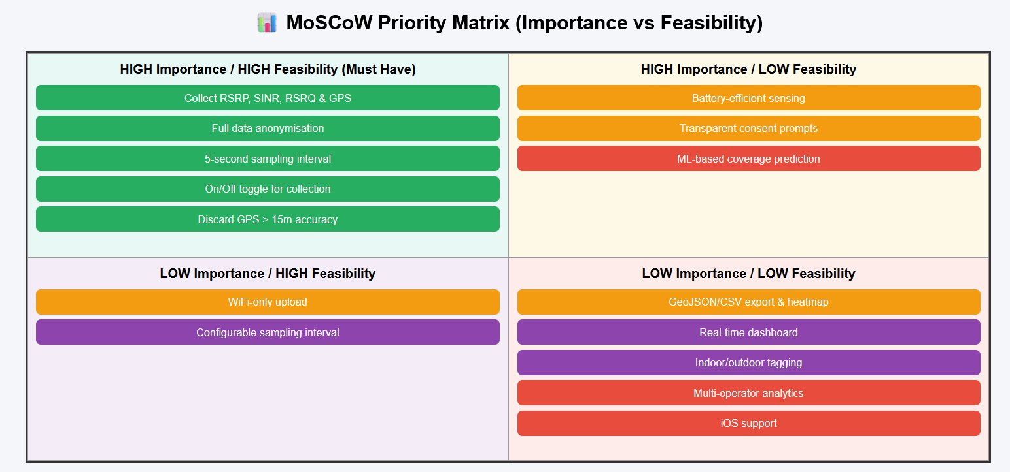Figure 3: Requirement priority matrix visualisation

3.3 Summary by Priority
Priority | Functional | Non-Functional | Total
Must Have | 3 | 2 | 5
Should Have | 2 | 2 | 4
Could Have | 3 | 0 | 3
Won't Have (now) | 3 | 0 | 3
Total | 11 | 4 | 15

Table 3.3: Requirements count by priority and category
3.4 Detailed Justification by Priority Level

3.4.1 Must Have Requirements
These five requirements form the Minimum Viable Product (MVP). All are high importance and high feasibility, meaning they are both critical to stakeholder satisfaction and straightforward to implement using the Android Telephony API.

- Collect RSRP, SINR, RSRQ + GPS; the fundamental data the entire system is built upon. Without this, the application has no purpose. Confirmed as the core KPI set by MTN/Orange engineers.
- Full data anonymization; 56% of willing users made this a hard condition. Failure to implement this would likely prevent widespread adoption and violates data privacy best practices.
- 5-second sampling interval; the industry minimum established by engineer interviews. Less frequent sampling reduces data quality below operational usefulness.
- On/Off toggle for data collection; 36 users explicitly requested user control. This is a simple UI feature that directly addresses the #4 user reluctance factor (app permissions / control anxiety).
- Discard GPS readings >15m accuracy; ensures that geospatially inaccurate records do not corrupt the coverage prediction model. Technically simple to implement via Android Location API accuracy fields.

3.4.2 Should Have Requirements
These four requirements are strongly desired but involve moderate implementation complexity. They are targeted for inclusion in the v1.0 release following the MVP core.

- WiFi-only upload; protects users with limited mobile data. Addresses reluctance factor #3 (excessive data usage). Feasible via Android NetworkCapabilities API.
- Battery-efficient background sensing; the #2 user reluctance factor. Requires careful use of Android WorkManager or JobScheduler for battery-aware background execution. High importance, moderate complexity.
- Transparent consent prompts; addresses privacy concern #1. Requires thoughtful UX design (informed consent flow, GDPR-style language). Medium complexity but essential for ethical compliance.
- GeoJSON / CSV export + heatmap; the preferred data format of operator engineers. Drives real-world utility of the system for MTN/Orange network planning teams.

3.4.3 Could Have Requirements
These enhancements are valuable but not essential for the core product. They are deferred to post-MVP iterations if time and resources allow.

- Real-time signal dashboard; improves user experience and may increase retention. Survey data shows users appreciate transparency about what is being collected. Medium feasibility due to UI rendering complexity.
- Configurable sampling interval; useful for engineers who may want finer or coarser granularity. Low priority for end users but easy to add as a settings option.
- Indoor/outdoor environment tagging; 53.5% of users reported indoor signal problems. While valuable, automatic environment detection requires sensor fusion (accelerometer, barometer, WiFi) adding significant complexity.

3.4.4 Won't Have (Current Phase)
These requirements are acknowledged as important for the project's long-term vision but are explicitly out of scope for this phase due to low feasibility or dependency on prior phases.

- ML-based coverage prediction model; the ultimate goal of the system, but requires substantial training data from a fully operational crowdsensing pipeline first. Cannot be built before data collection is working.
- Multi-operator comparative analytics; useful for comparing MTN vs. Orange coverage. Requires a more mature backend with operator tagging and significant data volume.
- iOS support; the team's reverse engineering focused on Android. iOS introduces a separate development stack (Swift/Kotlin vs. Java), significantly extending scope beyond the current project timeline.

4. Requirement Classification
Requirements are classified into two types: functional requirements describe what the system must do, and non-functional requirements describe how well the system must perform. A total of 16 requirements were identified: 8 functional and 8 non-functional.
We gathered the requirements through surveys (100 smartphone users in Buea), interviews with MTN and Orange network engineers, team brainstorming sessions, and reverse engineering of comparable applications such as OpenSignal and Network Cell Info Lite. This report classifies those requirements into functional and non-functional categories.

Classification Framework
Requirements are classified according to the standard software engineering distinction between functional and non-functional requirements:
- Functional Requirements (FR): Define what the system must do in other words, specific behaviours, features, and operations the application must perform.
- Non-Functional Requirements (NFR): Define how the system performs like quality attributes such as performance, security, usability, and reliability.

4.1 Functional Requirements
These are the specific things the app must be able to do. Each one is tied back to a source from Task 2.

Requirement | Description | Source
Collect signal metrics (RSRP, SINR, RSRQ and GPS) | App passively collects LTE signal parameters and GPS coordinates during use | MTN and Orange network engineers
Configurable sampling interval (default: 5 seconds) | System samples network data every 5 seconds; interval is user-adjustable | Engineer minimum threshold
Filter inaccurate GPS readings (above 15m accuracy) | Discard GPS readings with accuracy worse than 15 metres | Network planning standards
Anonymise all collected user data | All transmitted data must strip personally identifiable information before upload | 56 of 100 survey users
On/Off toggle for data collection | Users can start and stop data collection at any time from within the app | 36 survey users
WiFi-only upload option | Users may restrict data uploads to WiFi connections only | 16 survey users
GeoJSON / CSV export with heatmap visualisation | Data exportable in GeoJSON or CSV; app renders a coverage heatmap | Operator engineers
Transparent consent prompts | App clearly informs users what is collected and obtains explicit consent before collection begins | Privacy best practices and survey feedback

Table 4.1: Functional requirements with sources

4.2 Non-Functional Requirements
These define the quality standards the system must meet. They were drawn from user privacy expectations, technical benchmarks from engineers, and operational constraints.

Category | Requirement | Rationale
Privacy | Full data anonymisation before transmission | 57% of surveyed users would only share data anonymously
Performance | Battery-efficient background sensing | Battery drain was the second biggest concern among reluctant users (37.8%)
Usability | Minimal user interaction during collection | Passive collection is the core design principle
Reliability | GPS accuracy threshold of 15 metres or less | Inaccurate GPS makes coverage maps unusable for network planning
Data Quality | Minimum sampling rate of 5 seconds | Engineers confirmed this as the minimum acceptable threshold for meaningful KPI data
Security | Informed consent before any data collection begins | Regulatory compliance and ethical data collection practice
Scalability | System must aggregate data from large numbers of concurrent users | Crowdsensing only works at scale
Compatibility | Android platform support using TelephonyManager API | Target users are predominantly on Android; API access is required for signal metrics

Table 4.2: Non-functional requirements with rationale
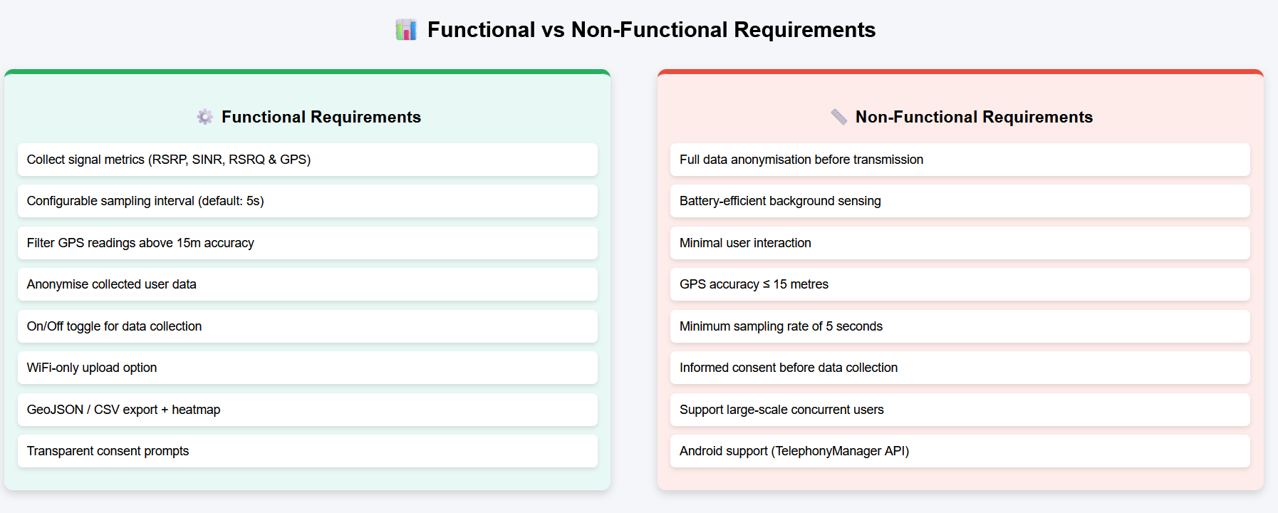Figure 4: Functional vs non-functional requirement classification overview

5. Software Requirements Specification (SRS)
CrowdSenseNet
Design and Implementation of a Crowdsensed Drive Test Mobile Application for Coverage Prediction

5.1 Introduction

5.1.1 Purpose
This document provides the complete Software Requirements Specification (SRS) . The purpose of this document is to specify the requirements for CrowdSenseNet, a system designed to address the lack of transparent network coverage data in Cameroon. By leveraging crowdsensing technology, the system aims to empower both consumers and network operators with real-time, accurate signal maps, replacing expensive traditional drive-tests with a community-driven mobile solution.”

5.1.2 Document Conventions
- Must Have: Critical requirements for the Minimum Viable Product (MVP)
- Should Have: Important features that add significant value but are not blocking
- Signal measurements are expressed in dBm for power and dB for quality

5.1.3 Intended Audience
- Developers and architects: focus on Sections 5.3 (System Features) and 5.7 (Architecture)
- Network engineers: focus on Section 5.1.5 (Definitions) and Section 5.6 (Data Requirements)
- Academic supervisors: focus on Section 6 (Stakeholder Validation) and the traceability matrix at the end

5.1.4 Project Scope
CrowdSenseNet is an Android application that turns ordinary smartphones into Class-2 IoT sensing devices. It passively collects cellular metrics (RSRP, RSRQ, SINR) to build real-time coverage heatmaps and predict coverage holes (RSRP below -110 dBm) using a machine learning model. iOS support is excluded in this phase due to API restrictions and scope limitations.
The Minimum Viable Product (MVP) covers: signal data collection (RSRP, RSRQ, SINR, GPS), local offline storage, backend data upload, a basic coverage map, and ML-based coverage hole prediction.

5.1.5 Key Definitions
Term | Definition
RSRP | Reference Signal Received Power. The primary LTE signal strength metric. Coverage hole threshold: below -110 dBm
RSRQ | Reference Signal Received Quality. Measures signal quality relative to interference
SINR | Signal to Interference-plus-Noise Ratio. Indicates signal clarity
Coverage Hole | Any location where predicted RSRP is below -110 dBm
UUID | Universally Unique Identifier. A random anonymous token generated on first launch
Crowdsensing | Collecting data passively from many users to build a picture of real-world conditions
Drive Test | Traditional method of measuring mobile coverage using engineers with specialised equipment in a vehicle

Table 5.1: Key definitions and terminology

5.2 Overall Description

5.2.1 Product Perspective
CrowdSenseNet is a standalone Android application operating within a three-tier architecture:
- Tier 1 (Client): Android app written in Kotlin for data collection and local SQLite storage
- Tier 2 (Backend): Python FastAPI server for data validation and PostgreSQL storage
- Tier 3 (Analytics): Python ML model for coverage prediction and heatmap generation

5.2.2 User Classes
- General Contributors: Non-technical users who passively contribute signal data.
- Network Engineers: High-technical users at MTN/Orange who access maps to fix problem areas.
- System Administrators: Experts managing the backend, database, and ML updates.

5.2.3 Operating Environment
- Mobile platform: Android 8.0 (API level 26) minimum
- Local database: Room (SQLite-based)
- Remote database: PostgreSQL with PostGIS for spatial data
- Network: 4G, 5G, or WiFi for data synchronisation

5.2.4 Constraints
- Battery constraint: Adaptive sampling is required to prevent unacceptable drain
- Geographic scope: Limited to the Cameroon bounding box (Latitude 1.65N to 13.08N)
- Permission dependency: Requires ACCESS_FINE_LOCATION and READ_PHONE_STATE permissions

5.2.5 Assumptions and Dependencies
- Users must grant required hardware permissions on first launch
- A minimum of 50 readings per 1 km squared is required before the ML model can generate a prediction
- Android TelephonyManager API must support SINR on the user's device (varies by Android version and chipset)

5.3 System Features

5.3.1 Functional Requirements
ID | Requirement | Priority
FR-01 | Single-tap session start/stop from the Home screen | Must Have
FR-02 | Auto-pause collection when the device is stationary for more than 30 seconds | Must Have
FR-03 | Auto-resume collection when device speed exceeds 5 km/h | Must Have
FR-04 | Capture RSRP, RSRQ, SINR, and RSSI via TelephonyManager API | Must Have
FR-05 | Capture GPS coordinates with every signal reading | Must Have
FR-06 | Discard readings where GPS accuracy is worse than 15 metres | Must Have
FR-07 | Store all readings immediately in local Room database | Must Have
FR-08 | Generate and store a random anonymous UUID on first launch | Must Have
FR-09 | Upload data to server over WiFi (default) | Should Have
FR-10 | Allow user to enable mobile data upload via Settings toggle | Should Have
FR-11 | Retry failed uploads automatically every 30 minutes | Should Have
FR-12 | Export collected data in GeoJSON and CSV formats | Should Have
FR-13 | Render a coverage heatmap on the Map screen | Should Have
FR-14 | Display a real-time signal dashboard on the Home screen | Could Have
FR-15 | Allow user to adjust sampling interval (5 to 30 seconds) in Settings | Could Have
FR-16 | Tag readings as indoor or outdoor based on sensor data | Could Have

Table 5.3: Functional requirements with IDs and priorities

5.4 External Interface Requirements

5.4.1 User Interface
- Modern Design: Built with Material Design 3 and responsive ConstraintLayouts
- Four core screens: Home (Dashboard), Map (Heatmap), History, and Settings
- All key actions must be reachable within 3 taps
- Supports English and French based on device language settings

5.4.2 Hardware Interfaces
- GPS: FusedLocationProvider API for battery-efficient location tracking
- Cellular modem: TelephonyManager for hardware-level signal parameter access

5.4.3 Software Interfaces
- Maps: Google Maps API or OpenStreetMap for the heatmap layer
- Server API: REST over HTTPS for all app-to-server communication
- Local DB: Room (Android) linked to SQLite for offline storage

5.4.4 Communication Interfaces
- All transmissions must use TLS 1.2 or higher
- WiFi-only upload is the default; mobile data upload is opt-in via Settings

5.5 Non-Functional Requirements

5.5.1 Performance
- App must launch and reach the Home screen within 3 seconds
- Heatmap must render within 4 seconds on a stable connection

5.5.2 Resource Constraints
- Background collection must consume less than 5% battery per hour
- Local storage is capped at 50MB with automatic deletion of synced records

5.5.3 Security
- The app must not collect name, email, IMEI, or IP address
- Backend API endpoints must require authentication tokens
- All data transmissions must be encrypted using TLS 1.2 or higher

5.5.4 Reliability
- No data loss during app crashes: all readings are written to local DB immediately
- Failed uploads are retried automatically every 30 minutes

5.5.5 Usability
- English and French language support based on device settings
- No more than 3 steps to enable or disable data collection

5.5.6 ML Accuracy
- The ML model must achieve at least 80% classification accuracy for coverage hole prediction
- Predictions require a minimum of 50 readings within 1 km squared to be valid

6. Validation with Stakeholders

6.1. Introduction
When you gather requirements from stakeholders, you end up with a list of things the system should do. But writing down those requirements is not enough on its own. You need to go back to the people involved and confirm that what you wrote actually matches what they meant. That process is called validation.
Validation is about making sure the requirements you gathered are correct, complete, and acceptable to everyone involved. It checks that the system you plan to build will actually meet real needs, follows the rules and regulations, and is realistic to implement. Without validation, requirements stay as guesses. With it, they become a solid base to build on.
For the Crowdsensed Drive Test Mobile Application, validation is especially important because the app involves data collection from real users in Cameroon. That means users, telecom operators, regulators, and supervisors all have a say in whether the requirements make sense.
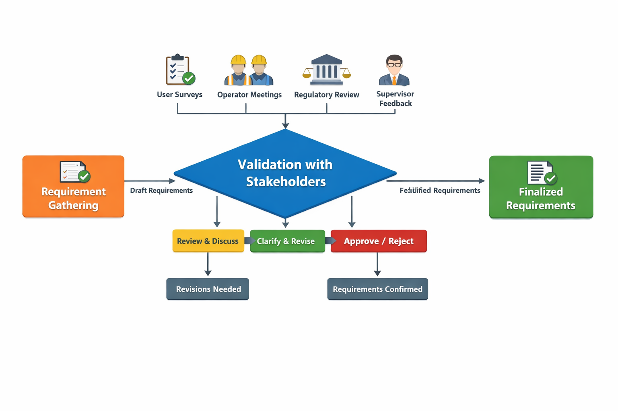
Figure 1: Overview of the stakeholder validation process flow

6.2. Why Validation is Important
There are four main reasons why validation is a step you cannot skip:
- Accuracy: It confirms that the requirements actually reflect what stakeholders said they need, not what the team assumed.
- Feasibility: It checks that the requirements can be built using the tools and technology available. For example, can Android actually give us access to SINR and GPS data? Yes, it can, so that requirement is feasible.
- Trust: It builds confidence among users, telecom operators, and supervisors that the system will do what it promises.
- Compliance: It makes sure the system follows legal and regulatory rules. For example, data anonymization has to meet Cameroon's telecom privacy standards before the app can collect any user data.
A simple example: if users say they need their data to stay anonymous, validation means going back and confirming with both the users and the regulators that removing names and phone numbers and storing only network parameters is enough. If it is not, the requirement needs to change before any design work begins.

6.3. Stakeholders Validation Methods
Different stakeholders have different concerns, so each group needs its own validation approach. The table below summarizes how each group was involved in the validation process:

Stakeholder | Method Used | Validation Example
Users (Smartphone Owners) | Follow-up surveys, prototype testing, feedback sessions | Show prototype with ON/OFF toggle. Confirm it meets their privacy expectations.
Mobile Network Operators (MTN, Orange, Nexttel) | Requirement review meetings with engineers | Confirm that RSRP, SINR, RSSI are useful for coverage prediction and match their standards.
Regulators (Telecom Authorities) | Compliance checks against national data protection laws | Present anonymization strategy and confirm it aligns with Cameroon's telecom regulations.
Supervisors (Lecturers) | Academic review of documentation and methodology | Ask if functional vs non-functional requirement classification follows proper software engineering.
Table 1: Validation methods used for each stakeholder group

Each group listed above plays a different role in the project, so the questions you ask them during validation are completely different. Users care about privacy and ease of use. Telecom engineers care about whether the data collected is actually useful for their work. Regulators care about legal compliance. And supervisors are checking whether the software engineering methodology is sound.
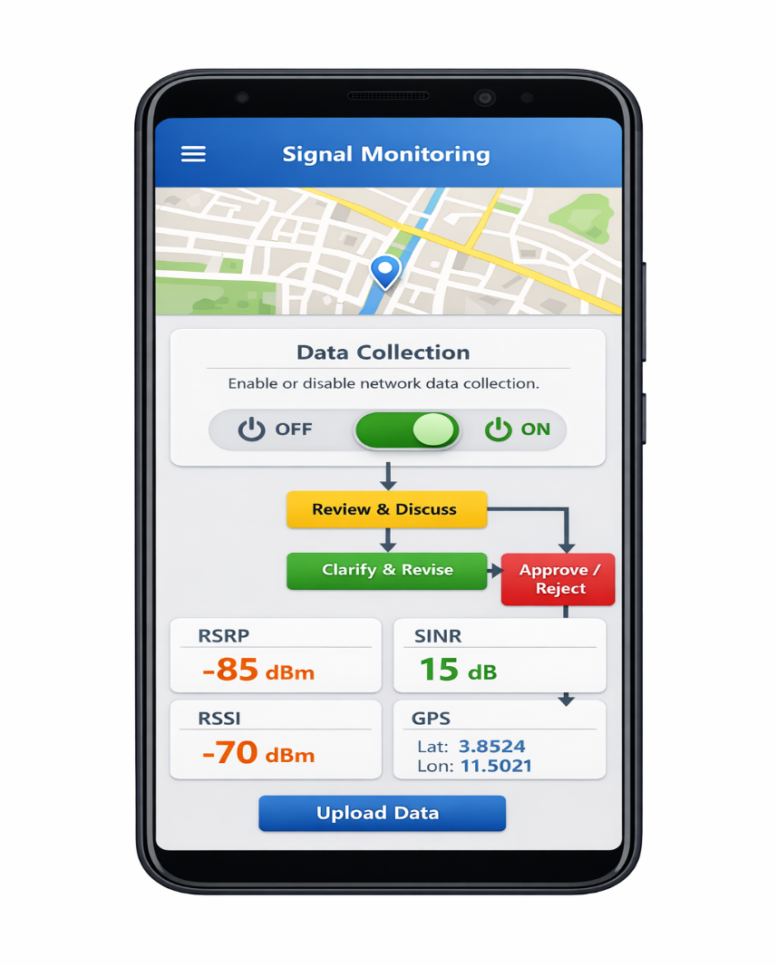
Figure 2: App prototype showing ON/OFF data collection toggle for user validation testing

6.4. Validation Techniques
There are four main techniques used to validate requirements with stakeholders. Each one works better in different situations:
- Requirement Review Meetings: You sit down with stakeholders, present the requirements, and ask for their feedback. This is the most direct way to catch anything that is unclear or missing.
- Prototyping: You build a simple version of the app and let users interact with it. This is more effective than just describing the app in writing, because people can see and feel what you are building. For this project, a basic prototype of the ON/OFF data collection toggle was shown to users to confirm it felt intuitive and private enough.
- Walkthroughs: You explain each requirement one by one to stakeholders, going through the logic step by step. This helps catch contradictions or gaps that are easy to miss when reading a document.
- Checklists: You use a structured list of questions to make sure each requirement is clear, complete, feasible, testable, and accepted by the right people. See Section 5 for the full checklist used in this project.

6.5. Validation checklist
The checklist below was used to evaluate each major requirement before it was accepted. Every requirement had to pass all five criteria before it could be treated as final. The table shows one example for each criterion:

Validation Criterion | Question to Ask | Example Outcome
Clarity | Is the requirement free of ambiguity? | "Collect RSRP every 5 minutes" is clear. "Collect data regularly" is vague.
Completeness | Does it cover all stakeholder needs? | Users want anonymity, so requirement added: "Data must be anonymized."
Feasibility | Can it be implemented with current tools? | Android APIs allow access to SINR and GPS, so yes, this is feasible.
Testability | Can it be verified during testing? | Battery usage of 5% per hour can be measured during device trials.
Acceptance | Do stakeholders agree with the requirement? | MTN engineers confirm usefulness of parameters. Users confirm privacy toggle.
Table 2: Validation checklist with example outcomes for each criterion
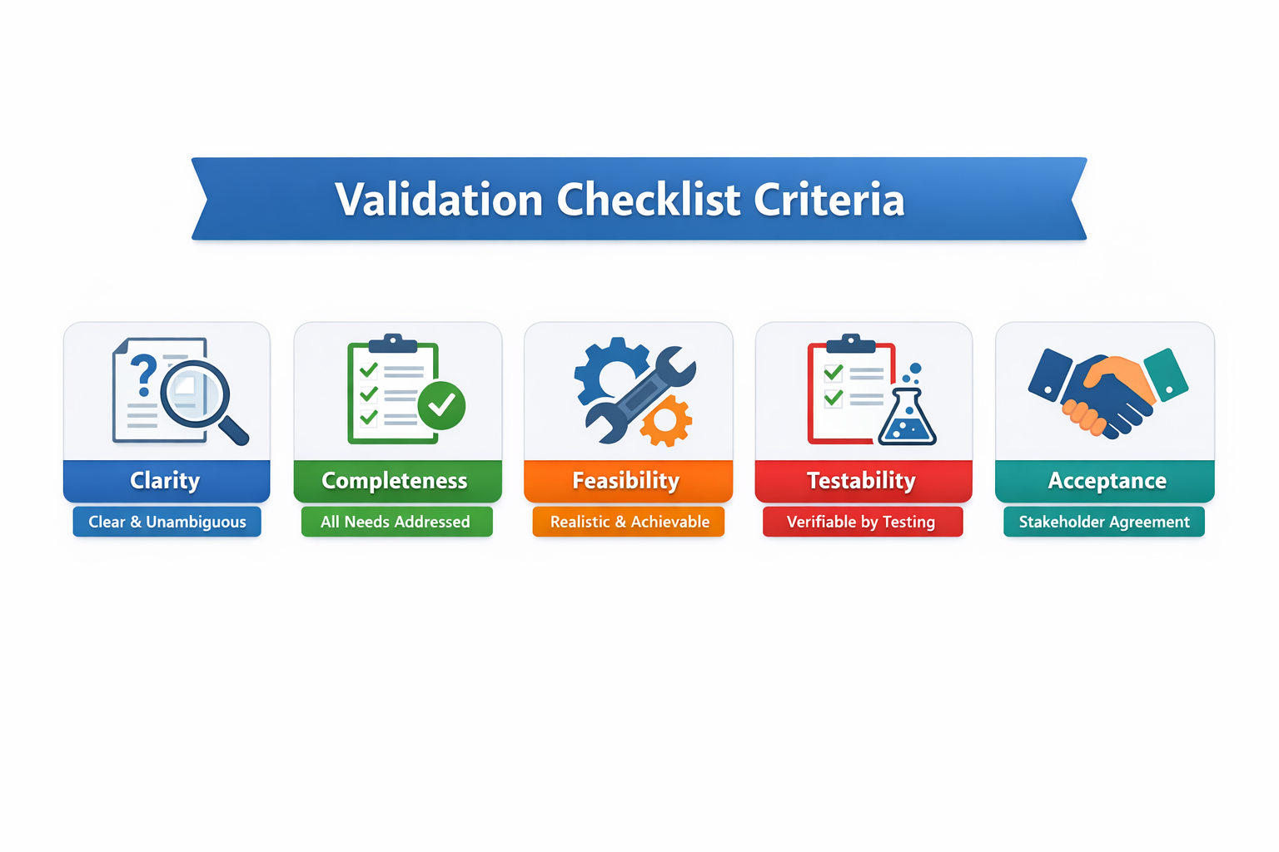
Figure 3: Visual summary of the validation checklist criteria
Each requirement in the final list for the Crowdsensed Drive Test Mobile Application was checked against these five criteria. Any requirement that failed even one of them was sent back for revision before being finalized. This process is what turns a rough list of stakeholder wishes into proper, testable system requirements.

6.6 Validation Outcomes
Running every requirement through this checklist produced the following key confirmations:
- Users confirmed they need anonymity and a clear ON/OFF control. These are now locked-in non-negotiable requirements.
- Telecom engineers confirmed that RSRP, SINR, and RSSI are the right parameters to collect and that they match the parameters used in their own internal systems.
- The anonymisation approach (removing all PII and using only a random UUID) was found to be acceptable under the relevant regulatory expectations.
- Academic supervisors confirmed that the functional and non-functional classification follows standard software engineering methodology.

CONCLUSION
This report has taken the raw requirements gathered in Task 2 and turned them into a solid, well-structured foundation for building CrowdSenseNet. The process was systematic: we reviewed every requirement for completeness, clarity, technical feasibility, and dependencies. We resolved four inconsistencies, clarified seven ambiguous requirements, and added eleven requirements that were missing entirely.

We then prioritised all requirements using the MoSCoW method, giving the development team a clear order in which to work. The five Must Have requirements define the MVP. The four Should Have requirements complete the v1.0 feature set. Everything else is clearly deferred or excluded with reasons given.

The classification exercise confirmed that the system has 8 well-defined functional requirements and 8 quality-focused non-functional requirements, all grounded in real evidence from stakeholders. The SRS formalises all of this into a document that developers, engineers, and supervisors can all read and work from.

Finally, validation with stakeholders confirmed that the requirements are correct, feasible, legal, and accepted by the people who will use and oversee the system. This step is what separates a guessed set of requirements from a confirmed one.

The team can now move into the design phase with confidence that what is being built is the right thing, built the right way, for the right people.

